Halifax Osteopaths
The Pain & Injury Clinic Limited


Health and Safety
COVID-19 Practice Policy Update

14/3/2021
V.05

Practice Covid-19 Policy V5 March 2021

Update to take us through the next phase of Covid-19

Introduction Page 3

General Practice Protocols

Masks and PPE Page 4

All Staff & Therapists attending work Page 5
with Coughs, Colds or Flu like Symptoms

Patients and Staff attending with Coughs, Colds Page 5
or Flu like Symptoms

Track and Trace Page 8
Osteopath Specific Page 9

Symptom Chart

How not to wear a mask picture Page 10

Osteopathic new Consent form Page 11

Introduction

The exceptional standards that we adhere to have undoubtedly contributed to the success of everyone’s business post lockdown and it is imperative that we maintain this going forwards.

However, one team member not following the Covid Secure protocols could have a severe impact on everyone. Fines of up to £10,000 are to be imposed on non ‘Covid Secure’ premises and it only takes one bad review to change the public perception on attending. We therefore insist that the practices and procedures we have implemented be continued and are grateful for your effort in maintaining the policy.

We hope that with the right procedures and protocols in place we will be able to continue working as we currently are and continue safely through the next phase of the pandemic. As infection numbers increase it is important that we should not become complacent and we are all have a role to play and a responsibility in maintaining a Covid-safe working environment.

Please continue to use the original document as the main policy and point of reference.

Whilst we appreciate not everyone has the same opinion on how we should approach the Pandemic and some patients or staff can be unconcerned or cavalier others may be extremely vulnerable or apprehensive about attending the clinic. Many also have friends and family who are shielding and may make the decision to come to the practice based on the procedures we have in place. Therefore, all staff and therapists need to follow the policy to ensure we are consistently delivering the promise of a Covid-safe experience.

Any Therapist or Employee not adhering to the guidelines of their governing body and the practice policy will be susceptible to government and local authority enforcement and Halifax Osteopaths will work in conjunction with the authorities as required.

Any therapist or practitioner who invites another Health Care professional to the practice is responsible for ensuring that all standards are met and adhered to and they accept the responsibility for that practitioner.

Halifax Osteopaths will accept no liability or financial penalty for individual
breaches of government, governing body or Public Health England policy as enforced by any authority.

General Practice protocols for all

Social distancing
Routinely maintain social distancing where possible and wear a mask when close to other staff members or patients.
If social distancing cannot be maintained (within 1m of another staff member) please wear a mask or face covering. Avoid congregating in enclosed areas.

Hygiene
Clean and sanitize hands and surfaces consistently before and after using communal items:
e.g. Kitchen equipment, telephones, handles etc.
Please dispose of PPE safely and do not leave laying around.

Waiting Room

Patients arriving early will be asked to wait in the entrance lobby (or if necessary outside, in their car) until their appointment time. To be helpful and courteous to all patients they should be continually advised of this when booking as during winter and when it’s cold and raining patients will be less agreeable to waiting outside. Therapists should be ready to commence their appointment on time, so patients are not waiting in reception any longer than necessary.

Patients will have received and replied to a text confirming they have not had symptoms of Covid, nor contact with anyone with symptoms. If this has not been done Patients will be asked to send the text on arrival and if they cannot do this, fill in a paper Covid Questionnaire.

Reception staff should ventilate the waiting room.

Patients are encouraged to use the track and trace application and QR code displayed in reception.

One-way system
Receptionists should enforce the use of the one-way system. Staff/Therapists leaving the building by the entry door should check with reception that an arrival is not expected.
Staff/Therapists should leave the premises secure when leaving by the exit (ask a colleague) and advise reception they are no longer on the premises (Emergency/fire) All therapists should continue to escort patients to the door and wipe all touch points.
Including handrails

Deliveries
Deliveries relating to business at Halifax Osteopaths are permitted - please inform the receptionists if you are expecting a delivery.

Staff Room/Office
- Ventilate
- Social Distance
- Do not congregate or over crowd- maximum of 3 people in any room at any time.
- Clean and Sanitize
- Wash all utensils and crockery in hot soapy water.
- Do not put worn masks on the table or worktop etc.

Screening
Any patient for any therapist should be screened for being in the at-risk category, their need to isolate or shield for any reason including travel quarantine and any symptoms of Covid-19 or contacts who have.

On booking
  - Therapist should screen all patients when booking further appointments.
  - Receptionists to screen Osteopath New bookings.
  - Where possible New Patient or Re-examination Case Histories will be taken over the phone.

Before any treatment commences
  - By therapist, either before treatment or by phone before appointment.

  - All patients are requested not to enter the building if they are experiencing symptoms of Covid-19.

  - If the patient requires a chaperone or a translator, then the accompanying person should also be screened alongside the patient before treatment commences. The additional person should be from the same household or ‘bubble’.

  - NO person with confirmed Covid-19 should enter the building under any circumstances until the 14-day isolation period has ended and the patient is no longer experiencing symptoms.

  - Patients who need to isolate if they have returned from a country not covered by the travel corridor exception should not attend the clinic until after their isolation period of 14 days has elapsed.

  - Patients feeling unwell from symptoms other than the advised cough/temp/altered taste & smell should be assessed on an individual case basis by the therapist. If in doubt treatment should be rescheduled.

  - Non-contact thermometers are available in the clinic for practitioners wanting to use them. Please ask receptionist for one if required.

  - If temperature above 37.8 then a second core temperature reading should be taken using a disposable thermometer. These are stored in the drawers in room 1,2 and 4.

Masks and PPE

All therapists should wear (minimum) Fluid Resistant Surgical Masks (FRSM Type IIR) and appropriate PPE whilst treating a patient.
Masks should be worn fully over the mouth and nose. Sessional masks which are removed between patients should be removed by touching the ties only and placed face down in the therapist treatment room. They should not be worn on the head, neck or chin area when not required. Do not place worn masks on shared surfaces. Bins are emptied daily except Saturdays when therapists in PPE should empty and replace the liners ready for Monday and not reception staff.

All patients should wear a Type 2 single use mask, provided on arrival, by Halifax Osteopaths for treatment. A face covering should be worn on entry to premises and wear one at all times whilst on the premises. If patients are unable to tolerate a face mask or covering it is recommended that the therapist use a visor or eye protection.

We would suggest therapists always ask their patients to try and tolerate a mask. Most treatment is not strenuous and therefore does not increase respiratory demand. The patient does not have to talk during treatment, and if struggling the patient can remove their mask whilst the therapist leaves the room for a couple of minutes.

Children under 12 are generally exempt from wearing a mask but will be asked to do so if they choose.

All Staff working at Halifax Osteopaths with Coughs, Colds or Flu like Symptoms

Please see attached sheet for symptoms of Cold/Covid-19/Flu

- any symptoms of Covid-19
- Cough
- Temperature 37.8 and above
- Loss of taste/smell
-do not come to work, ring 111 and arrange a test.
-return to work if negative, isolate for 10 days if positive.
-follow the advice and instruction from the NHS Track and Trace

Please let Andrew Cunnington know as soon as possible.

Patients attending with Coughs, Colds or Flu like Symptoms

- any symptoms of Covid-19
- Cough
- Temperature 37.8 and above
- Loss of taste/smell

do not attend until negative test obtained or have self-isolated/clear of symptoms for 10 days.

If a patient has cold and flu symptoms or feeling unwell and are unsure whether to attend the treating osteopath should speak to them and screen using their professional judgement.

If a patient needs to cancel at short notice due to Covid-19 symptoms the half fee should not be charged.

Track and Trace

The government has improved it’s track and trace capabilities with a mobile phone based application.

Therapist should turn off the blue tooth tracking facility in the App whilst wearing full PPE and receptionist whilst protected by the Perspex screen.

As cases rise exponentially around the country it is imperative that we all stick to the rules. The track and trace app will trigger a Tier 1 review in any health care setting, which can have the consequences of the building needing to be shut for 10 days, affecting all our practices and livelihoods.

The new track and trace rules supersede any Data protection or GDPR rulings and the clinic will be forced to reveal the identities of all patients and staff members present on the day of a trace.
The application tracks a user’s location automatically and through QR codes that you will see around the practice and all other premises.

Please be aware that only ‘Covid secure’ premises are allowed to trade, and the government has the power and ability to close down any business which isn’t adhering to the rules.

All therapists should have a daily record of patient’s names (timings) and contact numbers readily available should they be required for track and trace.

If a patient is tracked and traced and they disclose that the practitioner whom they attended was not wearing the full and appropriate PPE, then the service will close the premises during an investigation.
WHEN A PATIENT INFORMS US OF A TRACK AND TRACE PROCEDURE PLEASE ASK THAT WE ARE NOTIFIED AS HEALTHCARE RATHER THAN AS A CONTACT TO TRACK AND TRACE.
This prevents the compulsory self-isolation of Staff since they are wearing PPE and following safety protocols and procedures.

The PPE guidance from Public Health England does change regularly so please keep updated on your governing bodies requirements and adhere to the guidance.

OSTEOPATH SPECIFIC

Screening

The IO has once again changed its stance on screening and now suggests all new patients are screened before attending the clinic.
The initial screening is being done by the reception staff when the patients book an appointment. (see above)
The IO has produced a questionnaire that we will incorporate into our consent form and verbal screening.
All new patients and re-examinations should be screened in advance by replying to a Health Questionnaire, in line with the IO guidance and a confirmatory text within 24 hours of their appointments.
Continuation appointments should be screened by a text reply, prior to commencement of any treatment.

New Patients to be screened prior to commencing treatment for:

- Organ transplant
- Cancer treatment
- Bone Marrow or Stem cell transplant within 6 months
- Pregnant
- Lung conditions (COPD, Asthma, Bronchitis, Emphysema)
- Heart disease
- Diabetes
- Chronic kidney disease
- Liver disease
- Condition affecting the brain or nerves (Parkinson’s, Motor neurone, MS, Cerebral Palsy)
- Susceptible to the risk of infection due to medicine or immune system.
- Considered clinically obese. BMI 40 or above

These points are covered in the NP Medical History questionnaire. Please remember to screen returning patients for these conditions also.

Consent

The written Covid consent forms have changed. If patients have not confirmed by text, please ask all patients to sign the form once to agree, they no longer sign the form on every visit. Patients who attended using the original form should be made aware of the changes/additional tick boxes.
Before commencing with treatment please ask every patient if they have developed any symptoms of covid-19 and log it on the notes.

Every treatment

Please mark clearly on each treatment clinic notes that
- correct PPE was worn,
- patient was screened for symptoms, isolation and contact

PPE

Masks
It is recommended that osteopaths wear IIR Fluid Resistant Surgical Masks when providing direct care within 2 metres.
Patients are recommended to wear a face mask or face covering during the consultation to mitigate the risk of droplet transmission
If patients are unable to tolerate a face mask or covering (see specific guidance for these instances), it is recommended that the osteopath use a visor or eye protection (see below)

Gloves
The guidance on PPE has also been updated and the allowance of professional judgement removed from the wearing of gloves.
- Gloves must be worn when providing direct care to patients within 2metres.
- Gloves must be worn if conducting dry needling/acupuncture
- Gloves must be worn if undertaking intra-oral techniques
- If gloves are not available for any reason hands must be sanitised before and after the treatment

Aprons
Aprons must be worn to protect clothes when contamination is anticipated or providing direct care within 2 metres.

Visor/eye protection use
Visors/eye protection are considered to be required by osteopaths on a risk assessment basis (i.e. when blood and/or body fluid contamination to the eyes or face is anticipated).

We recommend you consider your patients’ views and utilise the use of visors or eye protection where this will support patient confidence in your services.

Availability
Whilst the availability of PPE remains sustainable Halifax Osteopaths will continue to supply PPE to Osteopaths and Staff. We retain the right to withdraw this provision.

Aeration/ventilation
It is no longer considered necessary for osteopaths to maintain a fallow period for aeration after each patient.
It is recommended that enough time is left between patients to allow for a thorough cleaning of the clinic room to be undertaken in line with the guidance previously published.
It is recommended that osteopaths perform an air exchange of the clinic environment at the end of a session of use (i.e. during breaks and at the end of the day) or while decontaminating the full clinic environment (common areas and treatment rooms).

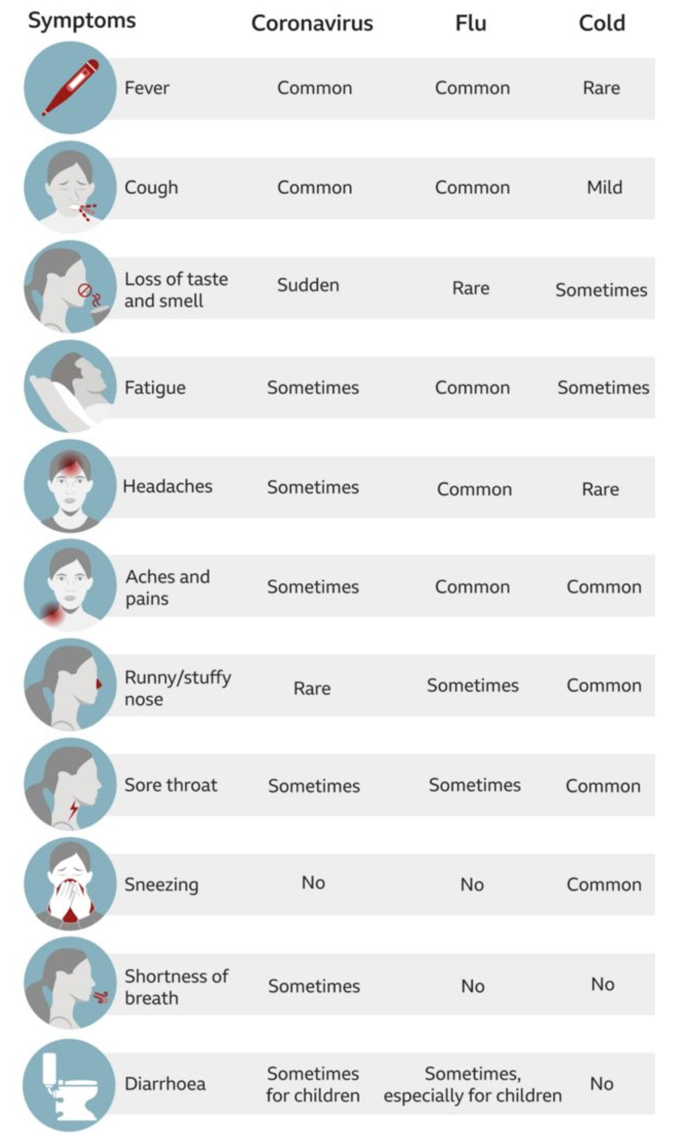

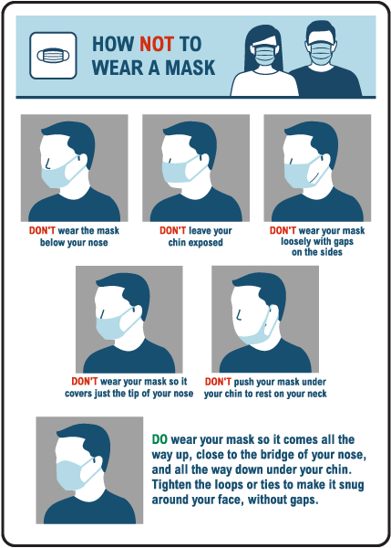

CORONAVIRUS RISKS: WRITTEN CONSENT TO TREATMENT

Patient Name: Patient DOB: If you are under 16 years of age, this consent should be signed by a parent or guardian.

Although it is legally acceptable for the Halifax Osteopaths to remain open and provide you with treatment, not least because this can help relieve pressure on the NHS, it is important that you understand the risks involved. These risks are minimal, and we are doing all we can to avoid any possibility of contamination, but the decision to go ahead with treatment must be yours and must be based on the best information we have.
Therefore, please read the information below and, if you agree to proceed, sign the consent form at the bottom.

Staff Health:
All practitioners at Halifax Osteopaths monitor themselves daily for symptoms of COVID-19. None of those in clinic are currently exhibiting any signs or symptoms of the disease.
All practitioners conform with government guidelines on PPE and this is changed between each patient.

Premises:
All surfaces in the clinic which might be touched by patients are thoroughly cleaned, using detergent/disinfectant solution.
This includes chairs, desks, card machines, pens, door handles and doorbells. All floors are mopped with disinfectant at least once a day.
We are practising safe distancing wherever possible and no waiting room facilities are available at this time.

Patients:
Patients are asked to sanitize their hands on arrival and to wear face masks. We try to ensure that patients do not touch any unnecessary surfaces.
Hand sanitizer is available for everyone’s use throughout the clinic.
Appointments are interspaced with a gap in order to minimise cross-contamination and to allow time for cleaning.
Patients are requested to attend clinic on their own whenever possible unless a chaperone or translator is required. The accompanying person should be from the same bubble will also require screening prior to arrival and therefore the clinic should be advised in advance. Government track and trace protocols overrule GDPR and Data Protection and we are obliged to supply your contact details to the relevant authorities should a contact trace be triggered.

Ultimately, we are doing all that we reasonably can to minimise risk whilst remaining open. However, we cannot eliminate risk, especially as COVID-19 can be spread by those showing no symptoms.

- I understand that there is a risk of transmission of COVID-19 as a result of attending Halifax Osteopaths

- I Do not have any symptoms of COVID-19*

- I have not been in contact with anyone who has within the last 14 days*

- I am not under instruction to self-isolate or quarantine for any reason including travel*

- I agree that Halifax Osteopaths cannot accept responsibility for transmission of COVID-19 should I become infected.

- I have had the chance to ask any questions I wish to and understand that I can discontinue treatment at any stage if I wish.

- I understand that a face to face consultation involves close contact with the osteopath and the associated risk that this involves, and I can ask for a video/telephone consultation as an alternative if I would rather not attend*.

Signed ___________________________________ Date _____________

